Janet Davis

Co-Owner/Director

208- 853-2800

[Jteach62@msn.com](mailto:Jteach62@msn.com)

## Early Learning Children’s Center

7064 W. State Street

Boise, ID. 83714

Phone: (208) 853-2800

Fax: (208) 853-2800

http://www.earlylearningcc.com

**6:30 a.m.-6:00 p.m.**

**Monday-Friday**

**Ages 6 wks-12 years**

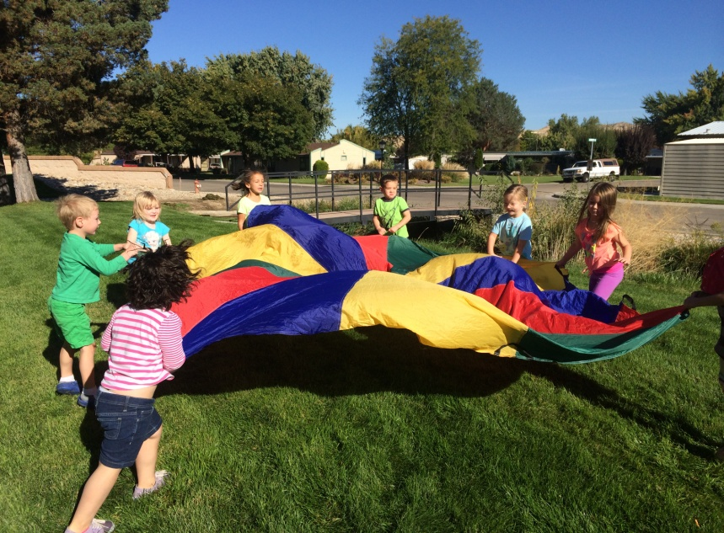

**Our Program**

* Boise City Licensed

* Teachers Pediatric CPR/First

Aid Certified

* Enrolled in QRIS: Working on

Star Rating

* Professional Development

* Low Ratios

* Sprinkler/Door Security System

* ICCP Approved

* Large fenced/secured

playground

* Indoor large motor area

* Classroom separated by age

groups

* Discount for siblings

* Co-Owner/Director thirty years

Experience early care and

Education

**Our Fees (**full time rates-part time rates available)

* $550 Infant/Toddler/Twos

* $450 Threes (potty trained)

Preschool

* $425 Kindergarten includes

transportation & in service

days

* $320/mo School-Age

Before/After

**Schools We Provide Transportation**

Shadow Hills, Pierce Park, Cynthia Mann, Collister, Taft, Lowell

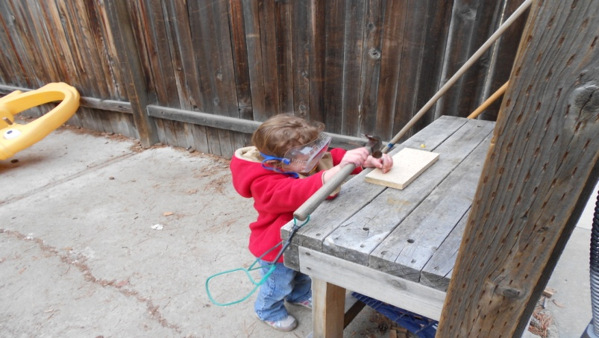

# 

## Early Learning Children’s Center LLC

**Our Schedule (sample)**

6:30—7:45 Children arriving

7:45-8:45 Breakfast/Little Town/Outside

9:00-9:15 Group

9:15-10:20 Work Time

10:20-10:30 Snack Time

10:30-10:40 Brush Teeth

10:40-11:15 Outside/Little Town

11:15-12:20 Work Time

12:20-12:30 Lunch

12:30-1:15 Outside/Little Town

1:15-3:15 Nap/Rest Time

3:15-3:20 Snack

3:20-6:00 Divide Preschool Groups Work Time/Outside Time

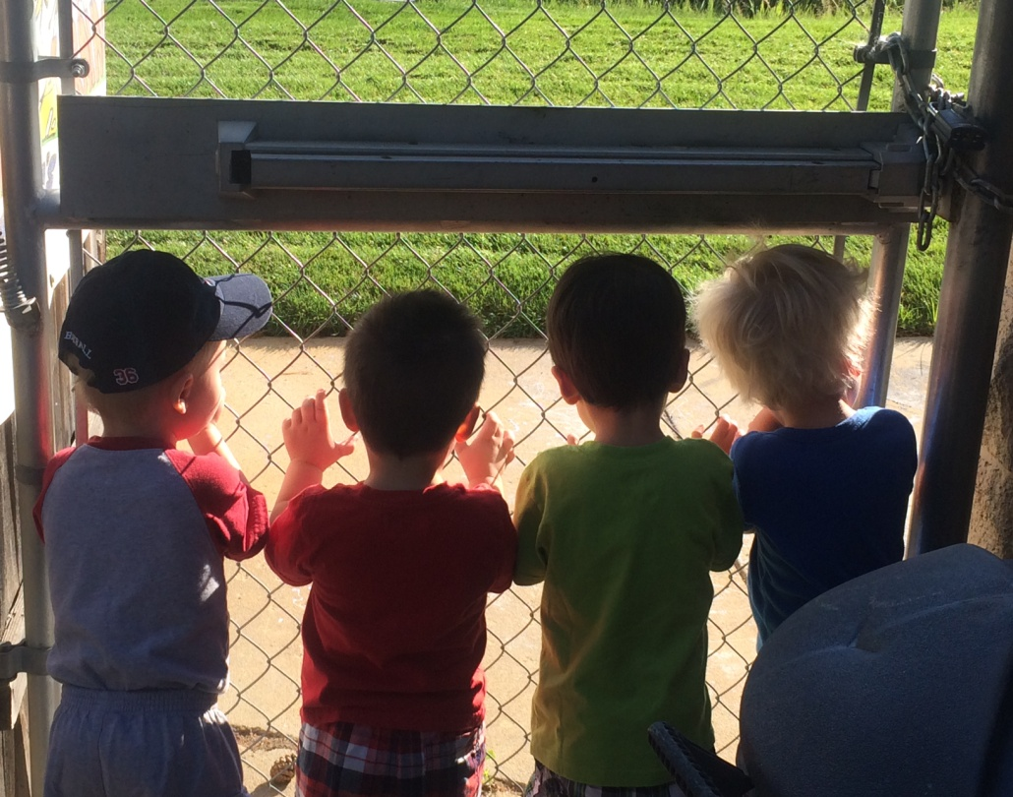

**Our Curriculum:**

Emergent, child-centered and play based. Planning the curriculum in each classroom will be based on:

*Knowledge of child development

*Understanding of developmentally

appropriate practices

*Sensitivity to children’s personal

experiences and interests

*CreativeCurriculumand the Idaho

Early Learning Guidelines



**Our Learning Centers:**

**Art:** creative representation through painting, drawing, collage

**Science:** materials for observing, predicting, experimenting, and documentation

**Blocks:** unit and other blocks for construction and cooperative play

**Dramatic Play:** pretend and developing social skills

**Writing Table:** materials for learning to write letters and numbers and conventions of print

**Manipulative:** puzzles, games and toys using small motor skills

**Book Corner:** books to read, share and a place to relax

**Our Parents**

Parents are integral part of our program; working together for children’s benefit. Parents are the child’s first teacher and understand their child best. Parents can provide information we can use to meet the interests and needs of each child.

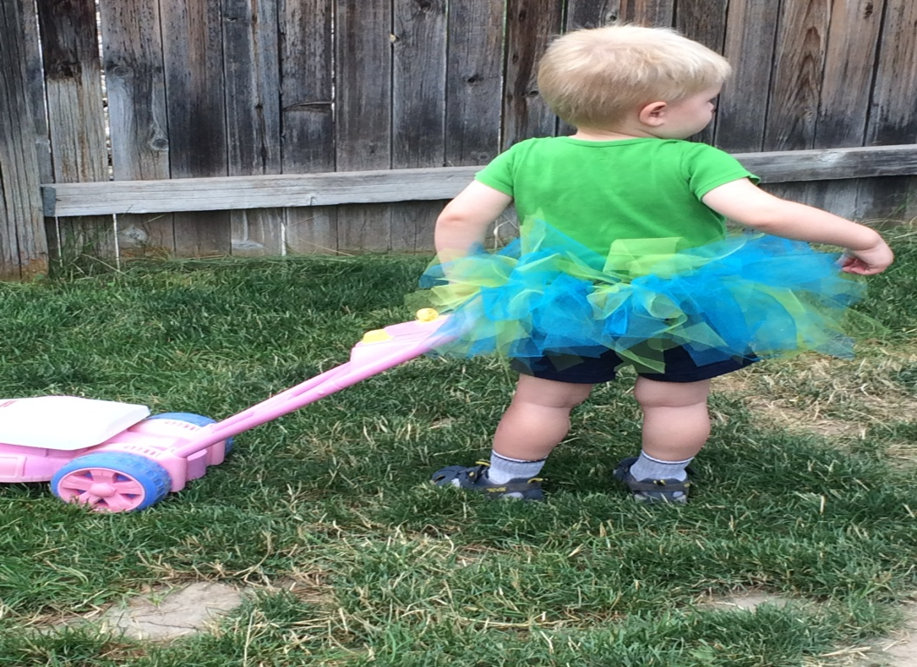

**Our Families**

Families are encouraged to participate in our after hour events that are scheduled throughout the year.

**Our Zookeepers**

Parent/teacher advisory board that meets monthly and plans after hour events and fundraisers for professional development and materials for the center.

### Welcome to Early Learning Children’s Center llc

**Our Mission:**

Provide quality childhood experiences to all children of Early Learning Children’s center LLC. Provide a safe and nurturing environment for all children to learn and grow at their own pace. Collaborate with families to strengthen relationships between owners/director, teachers and families.

**Our Philosophy:**

Based on the belief that children learn through active exploration and social interactions within a safe and nurturing environment.

Each day is made up with a balance of active, quiet, individual and group activities along with meal and nap/rest. Families are an integral part of our program. We partner with families to help lay a foundation that fosters a child’s “love of learning, and to strengthen their ability to acquire necessary skills as lifelong learners.

For information on open positions or to submit your resume, please visit our Web site at: www.lucernepublishing.com